## 

## **Application Engineering and Development – Assignment 3**

***Team Members:***

|  |  |
| --- | --- |
| **Name** | **NUID** |
| **Zeenia Singla** | **002980842** |
| **Ajay Sureka** | **002165619** |
| **Manthan Wadiwala** | **001099882** |

1. **Problem Statement:**

* To create a performance measurement solution to enable universities to measure the quality of the education they deliver to their students.
* To define your own ranking system for students to decide where they want to go for their studies.

1. **Solution:**

Performance metrics of the entities involved in a student’s graduation journey until after they graduate and get a full-time job is evaluated. Entities whose performance metrics is evaluated are:

Salary and job designation of alumni is tracked over a 5-year period to fetch course relevance and faculty contribution. In addition, a University Ranking System has been created allowing students to make an informed decision for choosing the right program in the right university.

The performance measurement timeline begins when the student joins a particular course in a university until they graduate and get a full-time job. Progression of a student is tracked by considering factors such as Employer Rating, Salary, Job Positions, etc. The proposed solution determines course relevance and faculty contribution in alumni’s career progression. This helps prospective students to decide from where they want to pursue their studies and also aids the university administrators to compare the performance of their academic units.

1. **Performance Metrics:**

Performance Metrics is the quantified data of an entity which lies in a particular range and we assign a certain number of points if that value lies within that range. The following metrics which were mentioned earlier will be explained in detail in this section:

1. **Graduate Performance**

The Graduate Performance Metric is determined by the academic performance and career progression of a student over a 5-year period. It includes the following factors:

* 1. **GPA**

This is the grade point average of the marks scored by the students in all their semesters combined. A high GPA means a high score. We assign the points to the GPA range as below:

|  |  |
| --- | --- |
| **GPA (0-4)** | **Points** |
| 0 - 1.5 | 0 |
| 1.6 - 2 | 1 |
| 2.1 - 2.5 | 2 |
| 2.6 - 3 | 3 |
| 3 - 3.5 | 4 |
| 3.6 - 4 | 5 |

* 1. **Current Salary**

This is the current salary of the graduate student in an organization. A high salary corresponds to a high points score. We assign the points to the Salary Range as below:

|  |  |
| --- | --- |
| **Current Salary (in $)** | **Points** |
| < 40000 | 1 |
| 40001 - 70000 | 2 |
| 70001 - 100000 | 3 |
| 100,001 - 120,000 | 4 |
| 120,000+ | 5 |

* 1. **Employer Rating**

Employer rating is the performance rating given by the employer to their employee i.e. the graduate student in an organization. An employee with Rating 1 will get 1 point and an employee with Rating 5 will get 5 points.

|  |  |
| --- | --- |
| **Employer Rating (1 -5)** | **Points** |
| 1 | 1 |
| 2 | 2 |
| 3 | 3 |
| 4 | 4 |
| 5 | 5 |

* 1. **Employment Position**

Based on the position of the graduate student in the organization, we assign the points. For eg. If the graduate student is an SDE Level 3, they will get 5 points.

|  |  |
| --- | --- |
| **Employment Position** | **Points** |
| SDE 1/DA 1/BA 1 | 3 |
| SDE 2/SDA 2/SBA 2 | 4 |
| SDE 3/SDA 3/SBA 3 | 5 |

* 1. **Extra Points**

If the graduate student meets the below critera, they will get extra points:

|  |  |
| --- | --- |
| **Extra Points** | **Points** |
| Got co-op (Yes) | 1 |
| Converting co-op to fulltime (Yes) | 3 |
| Is Full-Time Job in Fortune 500 Company? (Yes) | 5 |

1. **Faculty Performance Metrics**

The faculty performance metrics is determined by the following factors:

* 1. **Faculty Rating**

This is the rating given by the graduate students to their professors. Rating of 1 will get the maximum points and the Rating of 5 will get the least number of points

|  |  |
| --- | --- |
| **Faculty Rating (1 -5)** | **Points** |
| 1 | 1 |
| 2 | 2 |
| 3 | 3 |
| 4 | 4 |
| 5 | 5 |

* 1. **Research Papers**

The faculty will get points based on a given range of number of research papers published:

|  |  |
| --- | --- |
| **Research Papers** | **Points** |
| 1 - 5 | 1 |
| 5 - 10 | 3 |
| 10+ | 5 |

* 1. **Patents**

The faculty will get points based on a given range of number of patens published:

|  |  |
| --- | --- |
| **Patents** | **Points** |
| 1-3 | 1 |
| 3-5 | 3 |
| 5+ | 5 |

* 1. **Average GPA**

This is the average GPA of the students who studied the course taught by the particular faculty.

A higher GPA will correspond to a higher number of points.

|  |  |
| --- | --- |
| **Avg. GPA Course Wise** | **Points** |
| 0-1.5 | 0 |
| 1.6-2 | 1 |
| 2.1-2.5 | 2 |
| 2.6-3 | 3 |
| 3-3.5 | 4 |
| 3.6-4 | 5 |

* 1. **Average Graduate Performance Score**

This performance metric is calculated from the cumulative average of all the parameters in the Graduate Student Performance Metrics . A high average graduate performance score corresponds to more number of points.

|  |  |
| --- | --- |
| **Avg. Grad Performance Score** | **Points** |
| 0-0.5 | 0 |
| 0.6-1 | 1 |
| 1.1-2 | 2 |
| 2.1-3 | 3 |
| 3.1-4 | 4 |
| 4.1-5 | 5 |

1. **Faculty Contribution**

The Faculty Contribution Performance Metric determines how choosing a course taught by a particular faculty aided them to reach a certain position in an organization along with their income. Faculty contribution has the following factors:

The above factors are already explained in Graduate Performance Metrics.

1. **Course Relevance**

Course Relevance Metrics determine if the selection of a particular course by a gradute student aided them to get a full-time offer in the domain of their choice:

Current Salary and Employment Position are already explained in Graduate Performance Metrics

|  |  |
| --- | --- |
| **Course-job domain match** | **Points** |
| Yes | 5 |
| No | 0 |

**Determining Course Relevance-Job Relevance Factor:**

* Each course is linked to a domain. For instance, Application Engineering Development is linked to Software Engineering, Data Science and Engineering Methods is linked to Data Science.
* Each job position is linked to a domain. For instance, SDE is linked to Software Engineering, Data Analyst/Data Scientist is linked to Data Science.
* If job domain matches with the course domain, then weightage to course relevance is added in graduate career progression.

1. **Department Performance**

College Performance Metrics is determined by the cumulative average of all the previously defined performance metrics by department.

* 1. **Average Faculty Performance Score**

Average Faculty Performance Score is the cumulative average of all the factors in the Faculty Performance in a particular department.

|  |  |
| --- | --- |
| **Avg. Faculty Performance Score** | **Points** |
| 0-0.75 | 0 |
| 0.76-1.5 | 1 |
| 1.6-2.25 | 2 |
| 2.26-3 | 3 |
| 3.1-3.75 | 4 |
| 3.76-5 | 5 |

* 1. **Average Course Relevance Score**

Average Course Relevance Score is the cumulative average of all the factors in the Course Relevance Metric in a particular department.

|  |  |
| --- | --- |
| **Avg. Course Performance Score** | **Points** |
| 0-0.75 | 0 |
| 0.76-1.5 | 1 |
| 1.6-2.25 | 2 |
| 2.26-3 | 3 |
| 3.1-3.75 | 4 |
| 3.75-5 | 5 |

* 1. **Average Alumni Performance Score**

Average Alumni Performance Score is the cumulative average of all the factors in the Alumni Performance Metric in a particular department.

|  |  |
| --- | --- |
| **Avg. Alumni Performance Score** | **Points** |
| 0-0.75 | 0 |
| 0.76-1.5 | 1 |
| 1.6-2.25 | 2 |
| 2.26-3 | 3 |
| 3.1-3.75 | 4 |
| 3.75-5 | 5 |

* 1. **Average Alumni Salary**

Average Alumni Salary is the average salary of all the graduates in a particular department.

|  |  |
| --- | --- |
| **Average Alumni Salary (in $)** | **Points** |
| < 40000 | 1 |
| 40001 - 70000 | 2 |
| 70001 - 100000 | 3 |
| 100,001 - 120,000 | 4 |
| 120,000+ | 5 |

* 1. **Average GPA**

This is the cumulative GPA of all the students in a department.

|  |  |
| --- | --- |
| **Avg. GPA College Wise** | **Points** |
| 0-1.5 | 0 |
| 1.6-2 | 1 |
| 2.1-2.5 | 2 |
| 2.6-3 | 3 |
| 3-3.5 | 4 |
| 3.6-4 | 5 |

1. **University Ranking**

The University Performance Metrics is the cumulative average of all the performance metrics of all colleges. This data can be viewed by a perspective students which will help them decide which courses they want to opt.

* 1. **Average Faculty Performance Score**

This is the cumulative performance of faculty across all departments in a University.

|  |  |
| --- | --- |
| **Avg. Faculty Performance Score** | **Points** |
| 0-0.75 | 0 |
| 0.76-1.5 | 1 |
| 1.6-2.25 | 2 |
| 2.26-3 | 3 |
| 3.1-3.75 | 4 |
| 3.76-5 | 5 |

* 1. **Average Course Performance Score**

This is the cumulative performance score of all courses across all departments in a University.

|  |  |
| --- | --- |
| **Avg. Course Performance Score** | **Points** |
| 0-0.75 | 0 |
| 0.76-1.5 | 1 |
| 1.6-2.25 | 2 |
| 2.26-3 | 3 |
| 3.1-3.75 | 4 |
| 3.76-5 | 5 |

* 1. **Average Alumni Performance Score**

This is the cumulative performance score of all the students across all departments in a University.

|  |  |
| --- | --- |
| **Avg. Alumni Performance Score** | **Points** |
| 0-0.75 | 0 |
| 0.76-1.5 | 1 |
| 1.6-2.25 | 2 |
| 2.26-3 | 3 |
| 3.1-3.75 | 4 |
| 3.76-5 | 5 |

1. **Dashboard**

In this section, we explain the dashboard design of the Performance Metrics Software.

The dashboard has 2 views:

1. **Administrator View**
2. **Student View**

The main screen will be a login screen where the user can select role: Administrator or Student

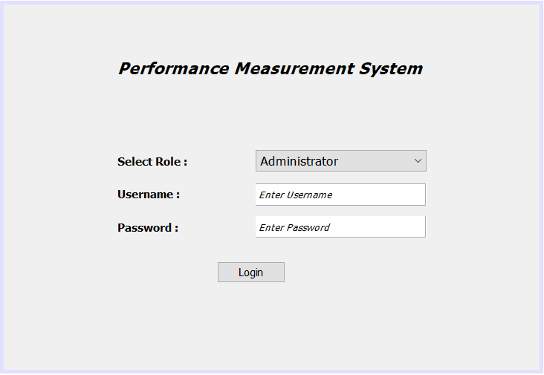

1. **Adminstrator View**

This View allows university administrators to view the performance metrics of Students, Faculty, Courses and Departments. The Administrator View will be the same for all the universities.

* 1. **Graduate Performance View**

The Graduate Performance View displays Performance Metrics of Students in different Programs.

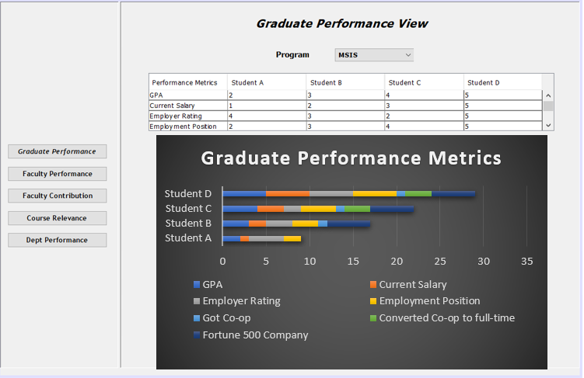

* 1. **Faculty Performance View**

The Faculty Performance View displays Performance Metrics of the faculty by course.

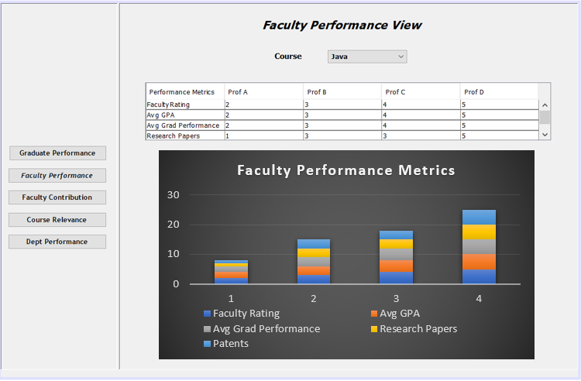

* 1. **Faculty Contribution View**

The Faculty Contribution View displays the Faculty Contribution of all professors by department.

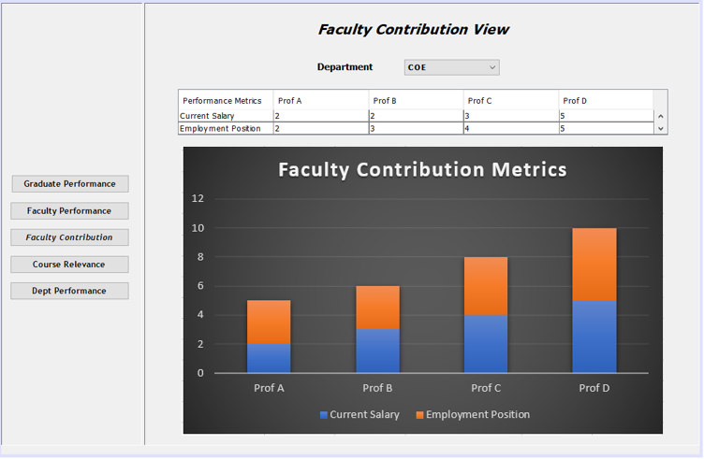

* 1. **Course Relevance View**

The Course Relevance View determines if students employment position depends on the course selected by them during their studies.

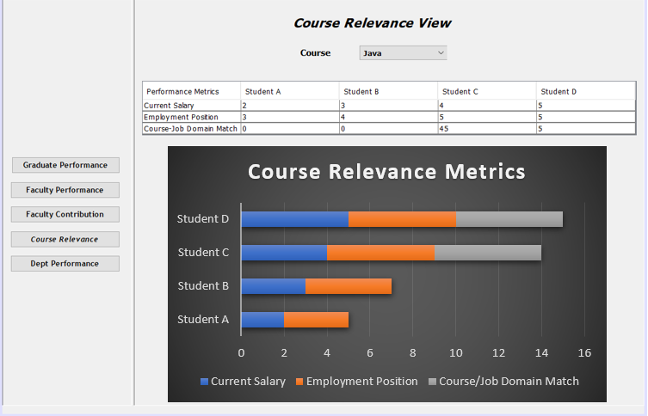

* 1. **Department Performance View**

The Department Performance View displays the cumulative average performance metrics of all entities department wise. It also displays the percentage of students with co-ops, full-time jobs and scholarships.

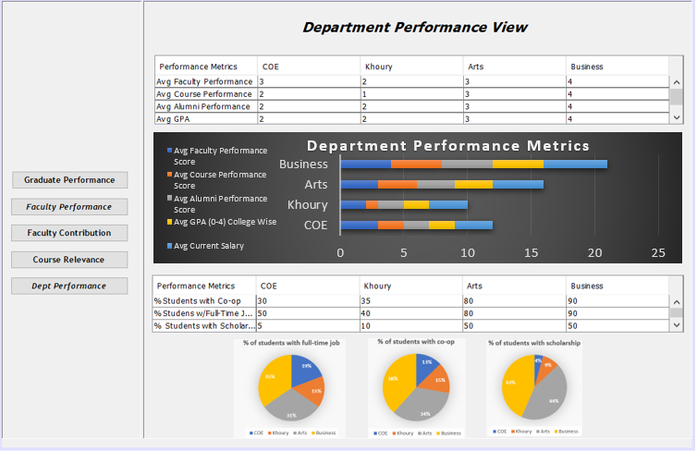

1. **Student View**

This View allows students to compare performance metrics of multiple universities to help them decide which career path they want to pursue.

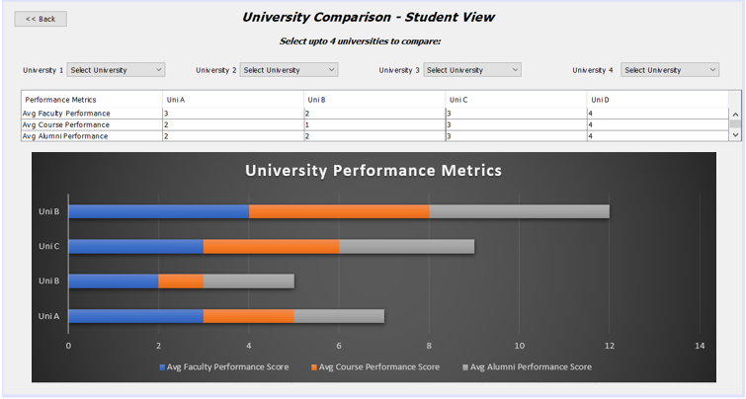

1. **Class Diagram**

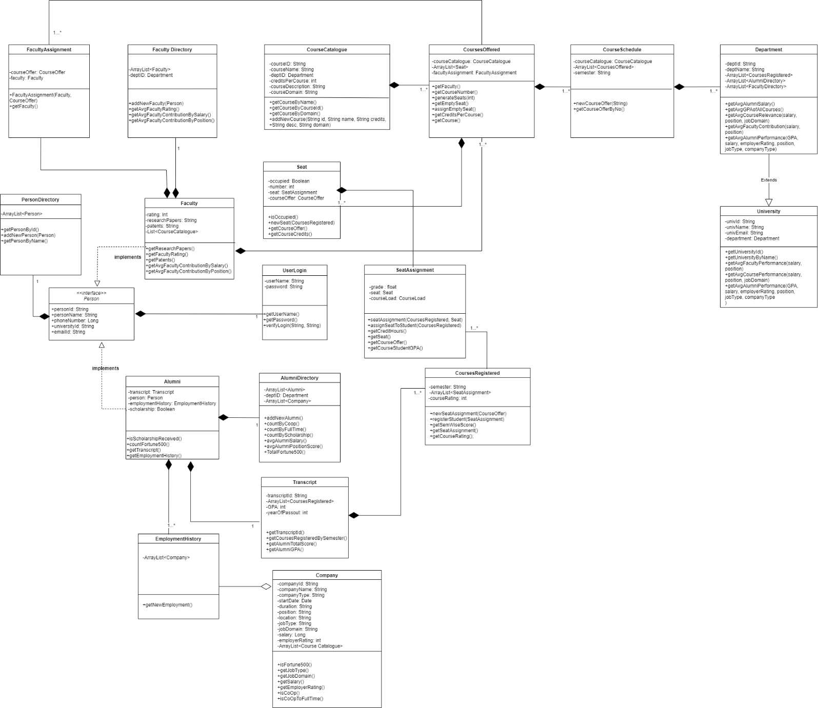



1. **Person**

Contains person details such as Person ID, Name, Phone Number, etc.

1. **PersonDirectory**

Contains details of all persons and adds new person

* getPersonById()
* getPersonByName()
* addNewPerson(): adds new person in the directory.

1. **UserLogin**

Contains username and password.

* getUserName()
* getPassword()
* verifyLogin(String, String): This method is used to verify the login details entered by the user.

1. **Alumni**

Contains alumni details, transcript details, employment history, scholarship received.

* isScholarshipReceived(): check if alumni has received scholarship or not.
* countFortune500(): count total fortune 500 companies in which alumni has worked over a 5-year period.
* getTranscript(): used to get transcript details of an alumni.
* getEmploymentHistory(): fetches the list of companies in which an alumni has worked over a 5-year period.

1. **Alumni Directory**

Contains details of all alumni and adds new alumni. It also measures alumni performance department-wise through factors such as counts total coops, full-time jobs, total scholarship, average alumni salary, average alumni position score.

* addNewAlumni(): adds new alumni.
* countByCoop(): counts total number of students with co-op in a department.
* countByFullTime(): counts total number of students with full-time in a department.
* countByScholarship(): counts total number of students with scholarship in a department.
* avgAlumniSalary(): calculates average alumni salary in a department.
* TotalFortune500(): counts total fortune 500 companies in which alumni have worked in a department.

1. **Company**

Contains all company details of the alumni.

* companyType: Fortune 500 or not
* jobType: Co-op/Full-Time
* jobDomain: Software Engineering/Data Science, etc.
* isFortune500(): checks if the company in which alumni works is Fortune 500 or not.
* getJobType(): returns the job type as co-op or full-time.
* getJobDomain(): returns the domain of job.
* getSalary(): returns salary of the alumni.
* getEmployerRating(): returns employer rating given to the alumni every time when the alumni changes position or during performance appraisal.
* isCoOp(): checks if the job type is co-op.
* isCoOpToFullTime(): checks if co-op is converted to full-time by tracking position in the same company.

1. **EmploymentHistory**

Contains list of companies in which an alumni has worked.

* getNewEmployment(): new employment is added in the directory.

1. **CourseCatalogue**

Contains list of all courses available and stores basic information like courseID, name, credits, department Id, etc.

* getCourseByName(): returns course by name.
* getCourseByCourseId(): returns course ID.
* getCourseByDomain(): returns domain of the course like Software Engineering, Data Science, etc.
* addNewCourse(id, name, credits, desc, domain): new course is added.

1. **CoursesOffered**

Represents courses that are being offered in a semester.

* getFaculty()
* getCourseNumber()
* generateSeats()
* getEmptySeat()
* assignEmptySeat()
* getCreditsPerCourse()
* getCourse()

1. **CourseSchedule**

Includes schedule of the courses for a given semester.

* newCourseOffer(String): schedule is added for the new course.
* getCourseOfferByNo(): returns course offered by number.

1. **CoursesRegistered**

Represents courses registered by a student for a given semester. Calculates semester grade average and gets course rating given by a student.

* newSeatAssignment(CourseOffer)
* registerStudent(SeatAssignment)
* getSemWiseScore()
* getSeatAssignment()
* getCourseRating()

1. **Seat**

Represents an available seat in a class.

* isOccupied()
* newSeat(CoursesRegistered)
* getCourseOffer()
* getCourseCredits()

1. **Seat Assignment**

Represents specific seat in a course is assigned to a student. Also calculates student GPA.

* seatAssignment(CoursesRegistered, Seat)
* assignSeatToStudent(CoursesRegistered)
* getCreditHours()
* getSeat()
* getCourseOffer()
* getCourseStudentGPA()

1. **Transcript**

Record of all the courses an alumni took during their course of program in a university.

* getTranscriptId()
* getCoursesRegisteredBySemester()
* getAlumniTotalScore()
* getAlumniGPA()

1. **Faculty**

Contains faculty details, faculty directory, faculty contribution to the graduate, research papers published, etc

* getResearchPapers(): gets the total research papers published by the faculty.
* getFacultyRating(): get the faculty rating given by alumni.
* getPatents(): used to get patent details of faculty.
* getAvgContributionBySalary(): gets the average salary received by the students under that faculty.
* getAvgContributionByPosition(): gets the average position received by the students under that faculty

1. **Faculty Directory**

Contains details of all faculty and adds new faculty. It also measures faculty performance department-wise through factors such as alumni salary, alumni position and also return faculty id and name.

* addNewFaculty(): adds new faculty.
* getfacultyById(): returns the faculty with id linked to specific string argument passed.
* getfacultyByName(): returns the faculty by name linked to specific string argument passed.
* getAvgFacultyRating(): gets the average faculty rating
* avgAlumniSalary(): calculates average alumni salary in a department.

1. **Faculty Assignment**

Contains the faculty assigned to specific course.

* getFaculty(): returns the faculty assigned to course.

1. **Department**

All department details are stored in the class. Average of performance metrics is calculated using different factors for making department performance comparison.

* getAvgAlumniSalary()
* getAvgGPAOfAllCourses()
* getAvgCourseRelevance(salary, position, jobDomain)
* getAvgFacultyContribution(salary, position)
* getAvgAlumniPerformance(GPA, salary, employerRating, position, jobType, companyType)

1. **University**

All university details are stored in the class. Average of performance metrics is calculated using different factors for making university comparison allowing students to compare different universities program-wise.

* getUniversityId()
* getUniversityByName()
* getAvgCoursePerformance(salary, position, jobDomain)
* getAvgFacultyPerformance(salary, position)
* getAvgAlumniPerformance(GPA, salary, employerRating, position, jobType, companyType)

1. **Sequence Diagram**

The below sequence diagram displays the interaction that takes place between the user and the performance measurement system:

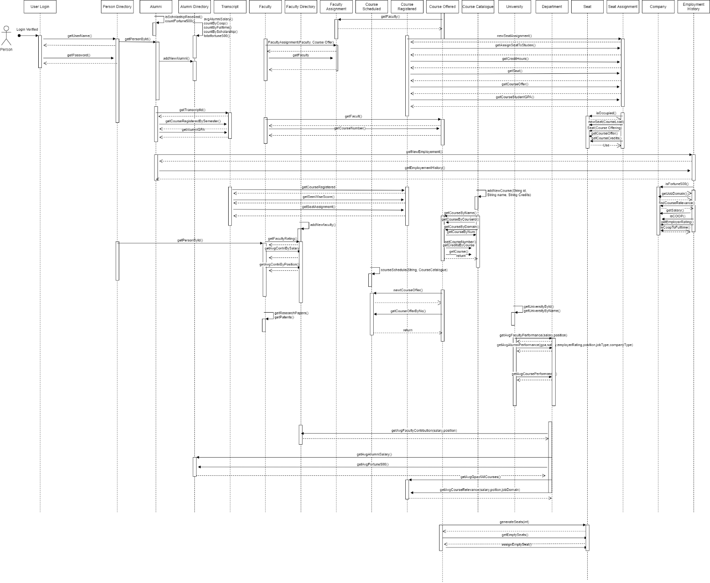



1. **Conclusion**

The proposed solution is able to analyse course relevance and faculty contribution holistically in career progression of graduates over a period of time. Unlike conventional university rankings, where metrics like student performance, acceptance rate etc. are taken into consideration - the proposed solution evaluates the outcome after graduation. This allows the university to mould its courses as per the industry demands ensuring relevant skill upgradation and better placement rate. In addition, the proposed solution also provides a university ranking system allowing students to compare university performance program-wise. Such a ranking system will allow students to make an informed decision of where they want to pursue their studies. Its horizon is far wide than prevalent systems as it is not only comparing course relevance, faculty performance but also comparing graduate’s career progression over a time period.